**Rossmoyne Senior High School Physics Unit 3 and 4 2021**

**Period Zero Test 1: Gravity and Motion**

**Name: __________________________________ Score: _________ /42**

**Time:** 45 min + 5 min reading

**Materials Provided:** This Question/Answer Booklet and the Formulae and Data Booklet

**Instructions:** When calculating numerical answers, show your working or reasoning clearly and include appropriate units. Give final answers to **three** significant figures. When estimating numerical answers, give final answers to a maximum of **two** significant figures.

1. The diagram below shows a 1.50 kg box sliding down a ramp at a constant velocity

25.00

* 1. Draw a labelled vector diagram below, showing the relationship between the forces acting on the box. [3 marks]
  2. Calculate the magnitude of the reaction force applied to the box by the ramp.

[2 marks]

* 1. Calculate the magnitude of friction acting on the box. [2 marks]

1. A toy company claims their latest water gun can fire a stream of water at 2.80 m s-1. Brook holds this water gun angled 15.00 above the horizontal, such that the nozzle is 1.40 m above the flat ground. Ignoring the effects of air resistance:
   1. Find the horizontal range of the water stream from Brook’s water gun. [4 marks]

* 1. Calculate the velocity of the water stream 0.200 s after it leaves the nozzle. Include the direction. [4 marks]
  2. Brook fires a second stream of water with the water gun now held perfectly horizontal, keeping the nozzle at the same height as before. Will this second water stream reach the ground with more, less or the same speed as the first stream? No calculation is required, but you must justify your choice. [4 marks]

1. Proxima b is a planet orbiting our neighbour star, Alpha Centauri. Observations reveal Proxima b is 1.30 times more massive than our own planet and orbits 7.50 Gm from Alpha Centauri. Proxima b’s orbit around its sun lasts 11.2 Earth days.
   1. Calculate the mass of Alpha Centauri. [4 marks]
   2. Calculate the acceleration of Proxima b as it orbits its sun. If you could not obtain an answer to part (a) you may use 2.60 × 1029 kg. [2 marks]
2. An ice skater performs a 3600 twirl in 0.800 s with arms extended (diagram A). A 3.00 × 10-6 kg ant is sitting on the back of her hand during the twirl.

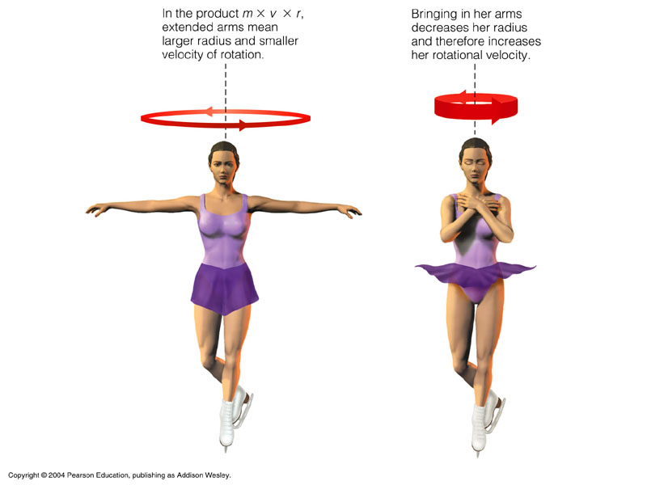

A

B

Estimate the centripetal force acting on the ant as the ice skater performs the twirl as shown in diagram A. Give your answer to an appropriate number of significant figures.

[5 marks]

1. A ball rolls down a frictionless ramp and then completes a vertical loop, as shown in the diagram below.

$$h_{1}$$

$$h_{2}=0.450 m$$

By first calculating the minimum speed the ball requires at the top of the loop to guarantee it will complete the loop, find the minimum initial starting height, $h_{1}$, of the ball. [6 marks]

1. Two identical 2.00 cm wide spherical objects are positioned such that their closest points are 16.0 cm apart.
   1. Draw the gravitational field in the space surrounding the two masses. [3 marks]
   2. Determine the mass of one of the spherical objects if the gravitational force acting on each of them is 3.60 × 10-18 N. [3 marks]

**End of Test**